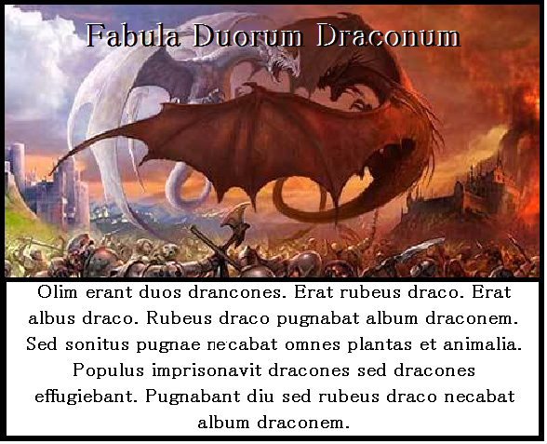
Once there were two dragons. There was a red dragon. There was a white dragon. The red dragon fought the white dragon. But the noise of the fight killed all the plants and animals. The people imprisoned the dragons but the dragons escaped. They fought for a long time but the red dragon killed the white dragon.
What is the Latin word for ‘but’?…______________________________________
Which tense is the verb ‘Necabat’ in?...____________________________________
Can you think of an English word that comes from ‘Sonitus’?_______________________
Here I’ve translated ‘Olim’ as ‘Once’. Can you think of a prettier translation?... __________________________________________________________
Why does the ending of the ‘Albus’ change to ‘Album’?__________________________
Find two different Latin connectives in the story!______________________________
Which dragon is the Subject of the last sentence?..._____________________________

