Orpheus and the Underworld
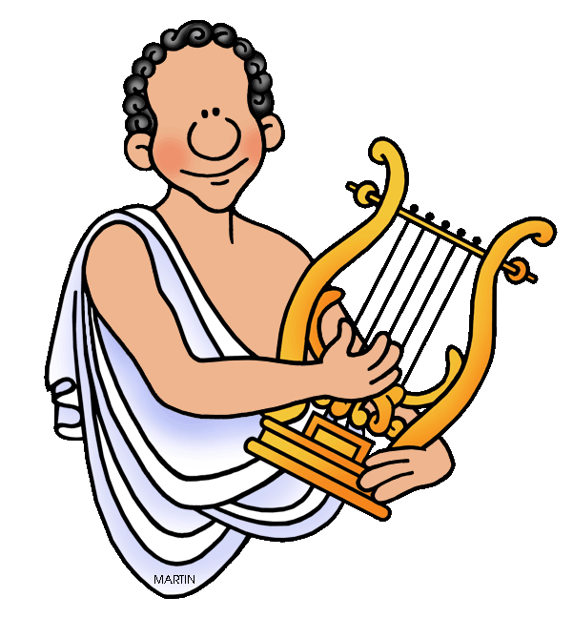
Once there was a great musician called Orpheus. He woke up one morning to sing about how he was getting married that afternoon.
Sadly, his wife had been bitten by a snake. The snake was deadly and it poisoned Orpheus’ wife. Before Orpheus could see her, she had passed away.
Orpheus was very upset because he really wanted to marry his wife. He decided to go and see the god of the Underworld, Pluto.
Pluto was sat having a banquet with lots of great food and drink with his friends when Orpheus arrived and he begged Pluto to let his wife come back to life.
Pluto didn’t know what to do. He had never let anybody come back to life before. It was then Orpheus had a great idea. “You have no music at your party Pluto. Let me sing a song for you!”
Orpheus sang the best song in the world and all the guests were entertained and happy. Pluto was so happy that his banquet was a success that he granted Orpheus one wish.
Orpheus wished his wife back to life and they left the Underworld together.
- Highlight the difficult words and write them below
________________________________________________________________
________________________________________________________________
- Why did Orpheus go to see Pluto?
________________________________________________________________
- What did Orpheus do to get a wish granted?
Gave Pluto money Played a song Had a banquet

