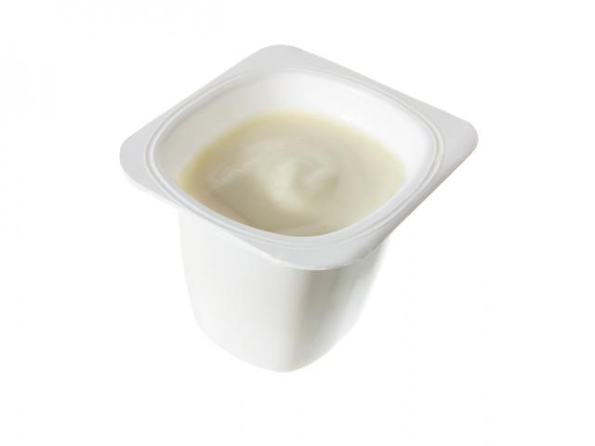
Pandora’s Box make:
Arts and crafts materials needed:
- A yogurt pot
- Pipe cleaners
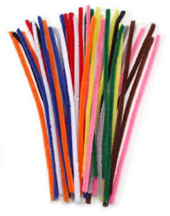
- Coloured card
- Safety Scissors
- Prit Stick or PVA glue
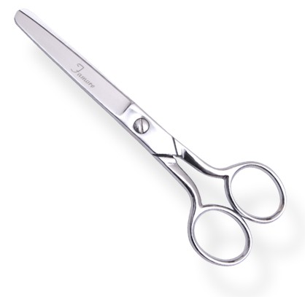

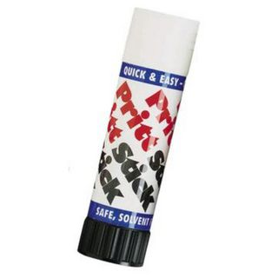

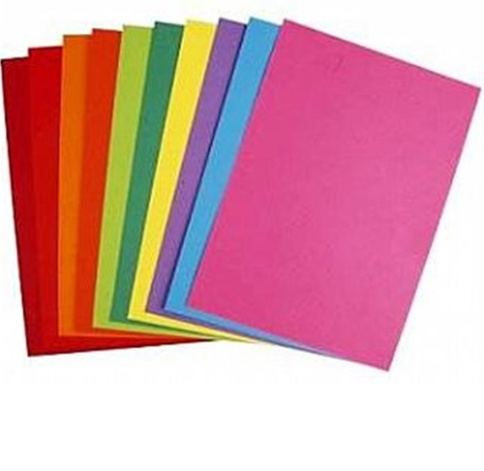

Process or making Pandora’s Box:
- Write the names of the things that escaped from Pandora’s Box.
- Cut around these names using the safety scissors.
- Take the yogurt pot and pierce holes in it with the pipe cleaners.
- Using the Pritt stick glue the names on the cut out pieces of card onto the end of the pipe cleaners.

