Passage Comprehension questions:

- What sea creature was on the sail of the ship Lupus sailed away on?
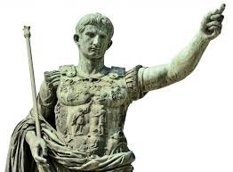
- A Dolphin B) A Seal C) An Elephant D) A Dog

- What was the name of Lupus’ rich Roman friend?

- Who was the Emperor Titus’ younger brother?
- Domitian B) Barry C) Julius Caeser D) Jonathon

- True or False: Romans wrote on wax tablets using writing equipment?

- BONUS QUESTION: Why is Threptus sad?

