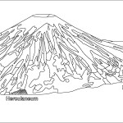
Pompeii

I was left to my own devices
_____ days fell away with nothing to show
And the _______ kept tumbling down
In the ______ that _______
Great clouds _________ over the hills
Bringing darkness from _______
But if you close your ________,
Does (it) almost feel like
Nothing changed at all?
And if _________ your _______,
Does (it) almost feel like
You've been here before?
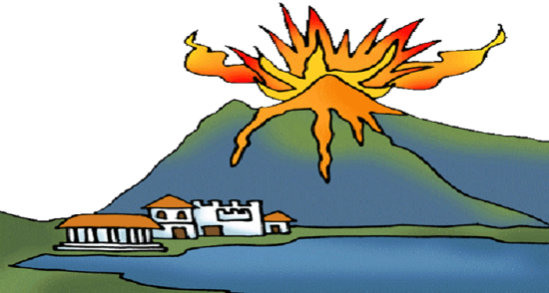
How am I gonna be an optimist about this?

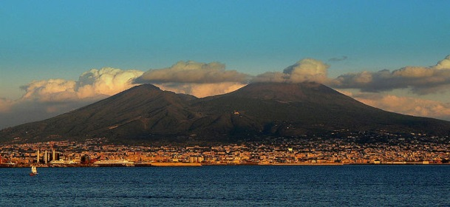
B∆STILLE
Latin | English | Word that comes from Latin
Volvo | I roll
Super | Above
Optimus | Best
Oculus | Eye
Antea | Before
Muri | Walls
Sentio | I feel
Urbs | City
Claudo | I close
Multi | Many
