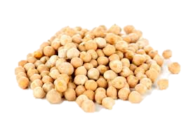
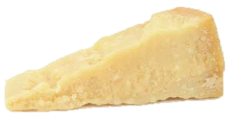
‘Erebinthoi syn Xeroi Tyroi’
Chickpeas and Cheese

Ingredients:

50g Chickpeas
25g Grated Parmesan Cheese
Olive Oil
Salt
Black Pepper

Method:
1. Soak the chickpeas in water for about 3 hours. Then and place in salted water.
2. Bring the to a boil and cook for 40 or until tender. Drain the water and allow to cool slightly.
3. Meanwhile grate the and add some black pepper.
4. Add the cheese to the chickpeas and with a fork. Add a little olive oil, mix this in and serve whilst still warm.

Fill in the Gaps with the words below:
Water Drain Minutes Cheese Mash

Translation of a roman text:
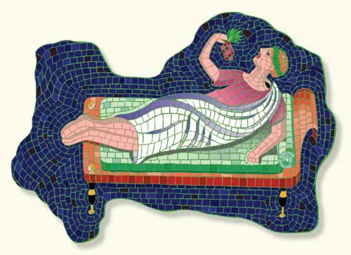
Chickpeas boiled in water are customarily eaten by many people, some serving them plain, others seasoning them with a little salt. Those who live where I do make a sort of flour out of dried cheese and sprinkle the chickpeas with this.

- Circle any difficult words. In groups, go through the text and help each-other to understand what has been highlighted in Red. Make notes below:

- What ingredients do you not like? Why?

- Are there any things you would add to make it better?

