Roman Army Basics

Composition
Legions – 5000 men
10 Cohorts per Legion
6 Centuries per Cohort
80 men per century
120 cavalrymen

Equipment
Short Sword (Gladius)
Large shield (Scutum)
Javelins (Pilum)
Dagger (Purgio)
Spear (Hasta)
Chainmail armour (Lorica Hamata)
Scale Armour (Lorica Segmentata)
Helmet
Greaves
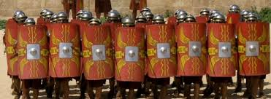
Basic formations
Lines – form in ranks of overlapping shields to present a solid wall.

Testudo – The tortoise, men on the outside face shields out while those in the middle hold there shields overhead to protect from missiles.
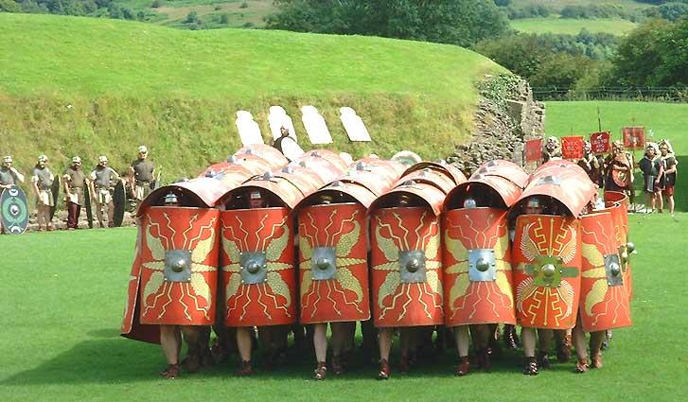
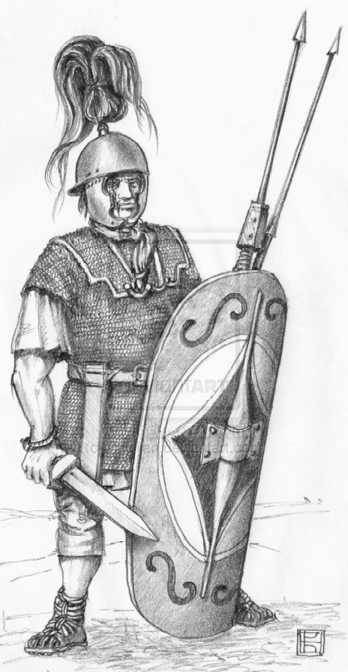
Short Sword
(Gladius)
Large Shield
(Scutum)
Chainmail Armour
(Lorica Hamata)
Javelins
(Pilum)
Helmet

