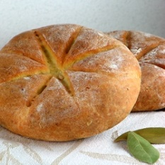
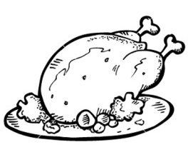
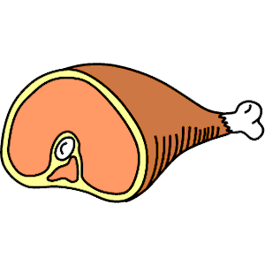
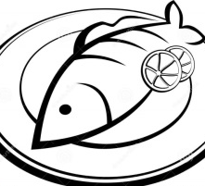
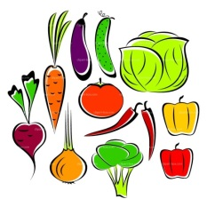
Roman Cooking – My Recipe
Honey: £2
Fish: £2
Grapes: £1
Goose: £4
Vegetables: £1
Ham: £4
Bread: 50p
Mouse: £2

Connect the picture to its price!

You have £8 to make a Roman meal, you get to use any food on the page before but make sure you can afford it!

Draw your roman meal here and label the food!

Describe what’s in your meal and why you chose those foods?

………………………………………………………………………………………………………………………………………………………………………………………………………………………………………………………………………………………………………………………………………………………………………………………………………………………………………………

