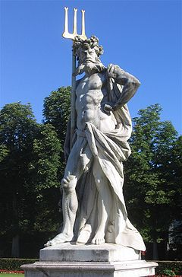
Roman gods hand-out – Can you fill in the gaps from the information you’ve just learnt?

Romans believed that gods lived in ST ________________________ so they prayed to those ________________________ES
Romans WO __________________________________ED temples but they could also pray at home.
Most Romans had small SH_______________________________ES in their houses which were like a small altar with a picture of their favourite G _________________ on.
Romans would also hold FE____________________LS and special days dedicated to the gods. There would be F________________________STS and parties for the G_____________________S
They would offer food, drinks and SAC___________________________S (of animals) as offerings to the gods as a sort of ‘C______________________T’. If they gave OF____________________INGS the gods would do as they were asked.
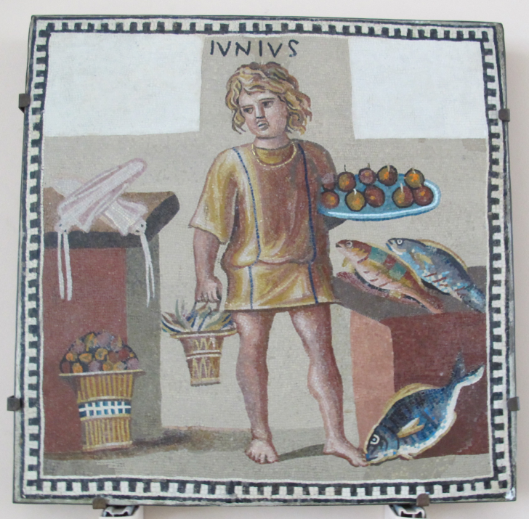

Romans P__________________________ED to all the different gods for different reasons:

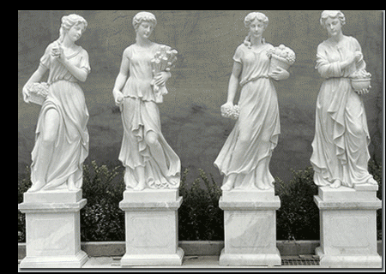
Pray to J______________O for a healthy family.

Pray to Venus for L__________________E.

