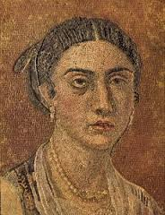
Roman Grandmother
Roman avia
This is Cornelia. She is an avia. Cornelia has a nephew who takes care of her. In Roman times, feminae needed legal guardians. The guardians would be the closest male relative and he would make all the decisions for them because women were not considered good enough to make their own decisions.
Cornelia, like all feminae during Roman times, is not allowed to vote. Also, she has a limited education. She finished ludum when she was 12 years old. A few years later, Cornelia married and had two filias.
She is a dressmaker and sells her clothes at the local forum. Cornelia sells lanas togas, and calceos.
Some words to help you:
forum – market lana – wool ludus - school
toga – toga calceus – shoes filia - daughter

Do you think grandmothers were important in Roman society?

_______________________________________________________________

What is the Latin word for shoes in the plural subject form?

What is the singular subject form of wool?
________________________________________________________________

