Married Roman women

We get some of our wedding traditions from the Romans. When she gets engaged, a Roman puella wears an anulum on the third finger of her left hand. When she gets married, she is dressed in white, wears a velum and is accompanied by a bridesmaid.
Roman puella normally get married when they are about XIV years old. The pater chooses a maritum and arranges the nuptias. It is more important to marry the right familia than to marry because you love someone. The pater controls all the members of his family and decides which man is rich and strong enough to marry his filias.
This is the way things were done at the start in Rome, during the Republicam. But once Roma has emperors, puellae have more control over their marriage and can also control their own pecuniam. They can even get divorced.
The most important task for a married woman is raising pueros et puellas and managing the domum. In poor families, women have to do all the work themselves; in richer families, women have servos and ancillas to help.
Even though a puella does not have a lot of control over who she marries, some couples do marry for love. Roman women can also host parties and can influence their maritos in the decision they make for their families.
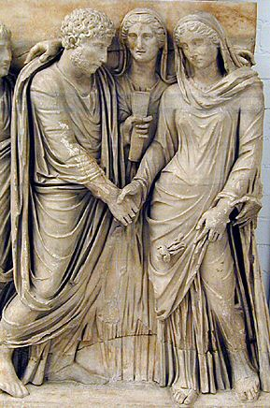
Answer these questions:
- What do you think an anulus is?

A frog a ring a bracelet

- What do you think a velum is?

A veil a skirt a dress

- How old are Roman girls when they get married?

4 years old 14 years old 24 years old

- Did Roman girls always have the same control over their marriage in the Roman period?

_______________________________________________________________________

_______________________________________________________________________

- Name two tasks Roman women were responsible for:

_______________________________________________________________________

_______________________________________________________________________

- Ancillas are maids. What is the Latin for only one maid? _________________________

- If you look at the picture on the previous page (this is from a tomb stone), do you think the couple love each other? Why (not)?

_______________________________________________________________________

_______________________________________________________________________

- Can you link the Latin words with the right translation?

Anulus girl

Puella husband

Velum daughter

Maritus veil

Filia ring

