Sailors and Centaurs

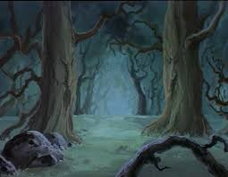
Olim nautae navigabant ad insulam.

______________________________________

Nautae videbant silvam, et ambulabant in silvam.
______________________________________

____________________________________

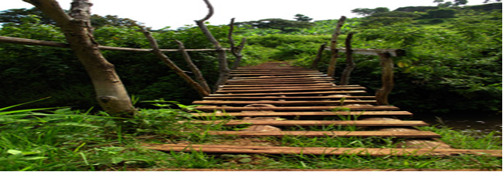
Nautae veniebant ad pontem.

_______________________________________
Nautae prudenter ambulabant trans pontem.

_______________________________________
Nunc ambulabant super flumen et videbant Centauros!

_______________________________________
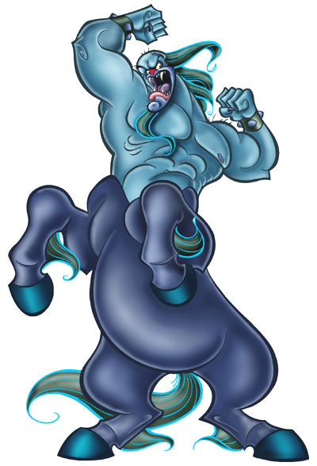
Centauri oppugnabant nautas sagittis.
_______________________________________
et nautae currebant a centauris.
_______________________________________
Periculum | Danger
Venio | I come
Flumen | River
Oppugno | I attack
Saggita | Arrow

