Puer - subject puella – subject magister – subject discipulus – subject





Puerum – direct object puellam – direct object magistrum – direct object discipulum – direct object

Pueri – subject (pl) puellae – subject (pl) magistri – subject (pl) discipuli – subject (pl)





Pueros – direct object (pl) puellas – direct object (pl) magistros – direct object (pl) discipulos – direct object (pl)

Ludus – subject charta – subject stilus – subject penna – subject



Ludum – direct object chartam – direct object stilum – direct object pennam – direct object

Ludi – subject (pl) chartae – subject (pl) stili – subject (pl) pennae – subject (pl)

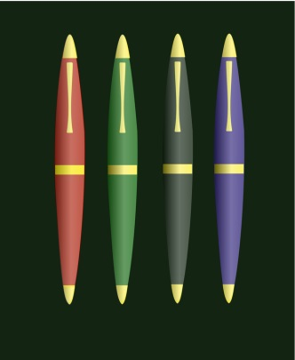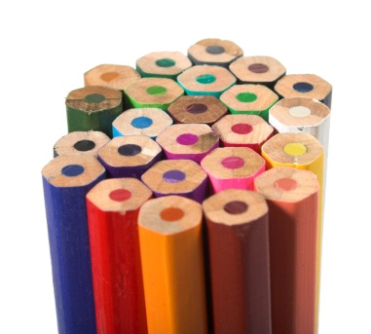

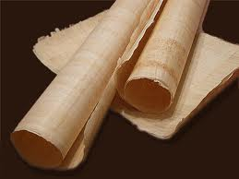



Ludos – direct object (pl) chartas – direct object (pl) stilos – direct object (pl) pennas – direct object(pl)

Regula - subject mensa - subject tabula – subject liber – subject

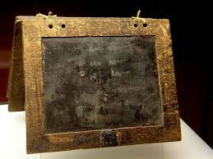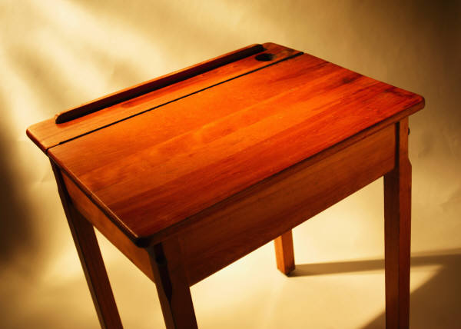

Regulam – direct object mensam – direct object tabulam – direct object librum – direct object

Regulae – subject (pl) mensae – subject (pl) tabulae – subject (pl) libri – subject (pl)

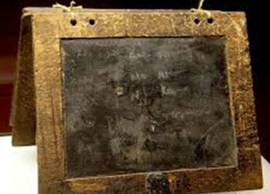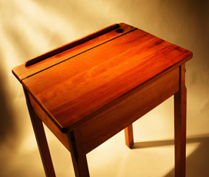





Regulas – direct object (pl) mensas – direct object (pl) tabulae – direct object (pl) libros – direct object (pl)