

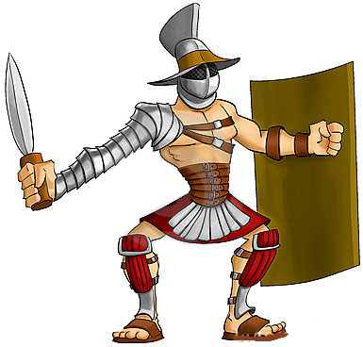A man called Spartacus had escaped from the Roman army, and his punishment was to become a _____________________________________________. Spartacus and other slaves escaped from the gladiator school with weapons from the _________________ .

Spartacus was very _______________ and ____________________, and he was the leader of the gladiators. Slaves from all around came to join Spartacus.

Many people in Rome were not happy that the gladiators and slaves escaped. The first of these was called Clodius, who sent 3,000 Roman soldiers to capture the gladiators. The gladiators were on a ____________ , so the soldiers waited at the bottom. The gladiators made ladders from _____________ to get down the hill, and they defeated the Romans.

C:\Users\Harry\AppData\Local\Microsoft\Windows\Temporary Internet Files\Content.IE5\V0SH0VCB\MC900149420[1].wmfAnother army of 2,000 soldiers was sent to capture the gladiators. Spartacus nearly captured the commander while he was ______________ , but he escaped. Spartacus won the battle and immediately captured the Roman camp.

Now Spartacus was great and powerful, and led his army to the ________________ so everyone could go home. His army disagreed and still wanted to fight, which scared the __________________ .. An army of 10,000 soldiers was sent to stop the slaves, and there was a big battle.

After Spartacus was captured.

1. Highlight any words that you find difficult in a coloured pencil
2. Why did the slaves join Spartacus?
3. Why do you think the slaves could beat the Roman soldiers in the first battles?
4. Who was scared by the slaves? Why?