(adapted from Plutarch)

A man called Spartacus had escaped from the Roman army, and his punishment was to become a slave who had to fight as a gladiator. Spartacus and 77 of the other slaves escaped from the gladiator school with weapons from the kitchen.
Spartacus was very strong and intelligent, and he was the leader of the gladiators. Slaves from all around came to join Spartacus and his men because they admired his escape and thought he was a hero.
Many people in Rome were not happy that the gladiators and slaves escaped. The first of these was called Clodius, who sent 3,000 Roman soldiers to capture the gladiators. The gladiators were on a hill, so the soldiers waited at the bottom. The gladiators made ladders from branches to get down the hill, and they defeated the Romans.
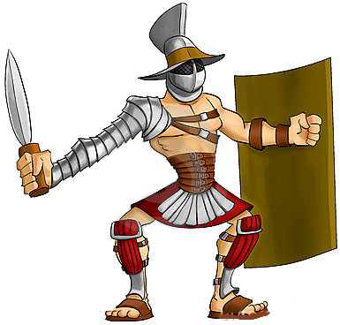
Another army of 2,000 soldiers was sent to capture the gladiators. Spartacus nearly captured the commander while he was bathing, but he escaped. Spartacus immediately captured the Roman camp, and his men won the fight against the Roman soldiers.
Now Spartacus was great and powerful, and led his army to the mountains so everyone could go home. His army disagreed and still wanted to fight, which scared the Romans. There was a huge war and some of Spartacus’ army were captured. An army of 10,000 soldiers arrived to stop the slaves, and there was a big battle.
Many armies were sent to capture Spartacus and his men, and the Romans even built a wall to stop them getting to Rome. Years after escaping from the gladiator school, Spartacus and his army of around 100,000 slaves were defeated by the Romans.

