Nouns (first and second declension): nominative and accusative
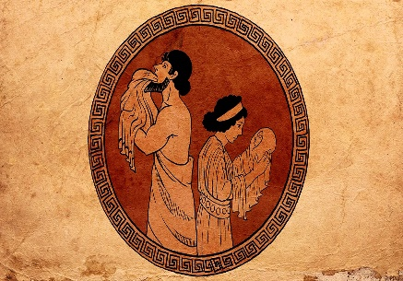
The simple sentence
The god eats the stone.

The god eats the stone.

Subject (Nominative)
Direct Object
(Accusative)

In Ancient Greek-
First declension feminine: νικη = victory
sg. Nominative νικ-η
Accusative νικ-ην
Second declension masculine: θεος = god
sg. Nominative θε-ος
Accusative θε-ον
Ten common nouns like νικη-
1 βοη shout
2 βουλη plan, also council
3 γη earth
4 δικαιοσυνη justice
5 εἰρηνη peace
6 ἐπιστολην letter
7 κωμη village
8 πυλη gate
9 ϕωνη voice
10 τιμη honour
As with verbs, it is important to distinguish the stem (which stays the same) from the ending (which changes). Again hyphens are used initially.
Ten common nouns like θεος-
1 ἀγγελος messenger
2 διδασκαλος teacher
3 δουλος slave
4 ἱππος horse
5 λογος word (also reason, story)
6 ξενος stranger,foreigner
7 ποταμος river
8 στρατηγος general, commander
9 στρατος army
10 συμμαχος ally

The Definite Article
This is the word for the. Latin has no equivalent, but in Greek it is very important. If there is no article, translate it as a.
eg. ὁ δουλος = the slave, δουλος = a slave.
Masculine:
Nominative: ὁ
Accusative: τον
Feminine:
Nominative: ἡ
Accusative: την

Word Order:
This is much more flexible than Latin. The verb need not come at the end, though it can.
ὁ στρατος ϕυλασσει τον ποταμον = The army guards the river.
Try and translate these sentences into English. Remember to look at the endings of verbs, as well as the nouns.
1 ἀκουω την βοην. _____________________________________
2 ὁ ἀγγελος διωκει τον δουλον. _____________________________________
3 ὁ ξενος ἐπιστολην γραϕει. _____________________________________
4 τον ἱππον αγετε. _____________________________________
5 διδασκομεν τον διδασκαλον. ____________________________________
6 ὁ δουλος ϕυλασσει την κωμην. ____________________________________
7 ϕερομεν την βουλην. ____________________________________
8 ὁ θεος ἀκουει τον ἀγγελον. ____________________________________
9 γραϕω ἐπιστολην. ____________________________________
10 ὁ θεος παυει τον ποταμον. ____________________________________

