Final Battle of Caractacus
Caractacus chose to fight his final battle with the Romans at the site of a hill fort that was easy to attack from and retreat to. This hill fort site was difficult for the Romans to attack. The Britain’s piled stones of the sides of the hill and waited in front of them, protected by the river.
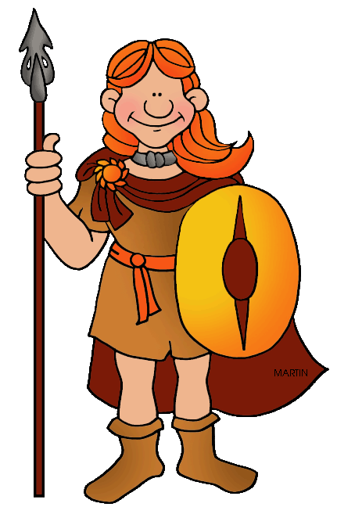
Caractus and the other generals moved between the men giving encouragement. Caracatus reminded the men that their ancestors had defeated Julius Caesar and encouraged them to defeat the Romans again in order to remain free. The men applauded Caracatus’ speech.
On the Roman side of the battle-line the Roman general Ostorius faced a challenge with the Welsh fort and its location.

The Roman generals had a meeting and decided the best way to attack the Welsh. Along with his brave men, Ostorius crossed the river where they were attacked with rocks and other missiles by the Welsh.
The Romans protected themselves by making a turtle shape out of the shields. The Romans smashed through the stone piles and fought hand-to-hand with the Welsh. Some Romans threw stones at the Welsh who had no armour. The Romans fought their way to the top of the hill fort and completely defeated the Welsh. Caractacus was captured along with his wife, daughters and brothers.

