Literacy Through Greek Beginners Language and Culture Test

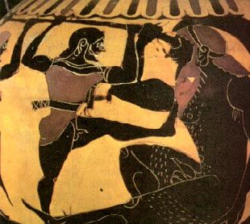

Duration: 25 minutes
Name

Part 1: Vocabulary and Grammar
Answer all questions

1 Write down the Greek into the English letters.
The first one has already been done for you.

Greek | English
Ζευς | Zeus
ἰδεα
κομμα

[2]
2 Write down the English into the Greek letters.
The first one has already been done for you.

English | Greek
drama | δραμα
mania
iris

[2]
Match the Greek words to the picture.
Example: Which one of these pictures shows ποταμος? Tick (✓) the correct box.
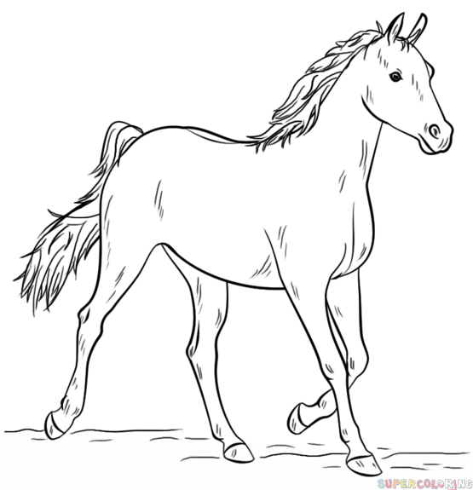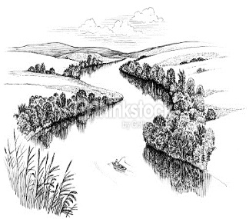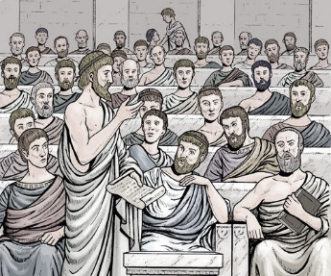

RIVER
COUNCIL
HORSE

✓
3 Which one of these pictures shows πυλη? Tick (✓) the correct box

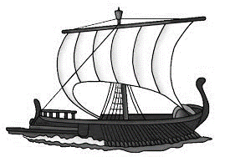
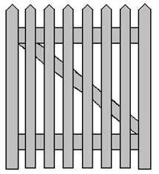

ROCK
SHIP

GATE

[1]
4 Which one of these pictures shows the action λεγω? Tick (✓) the correct box

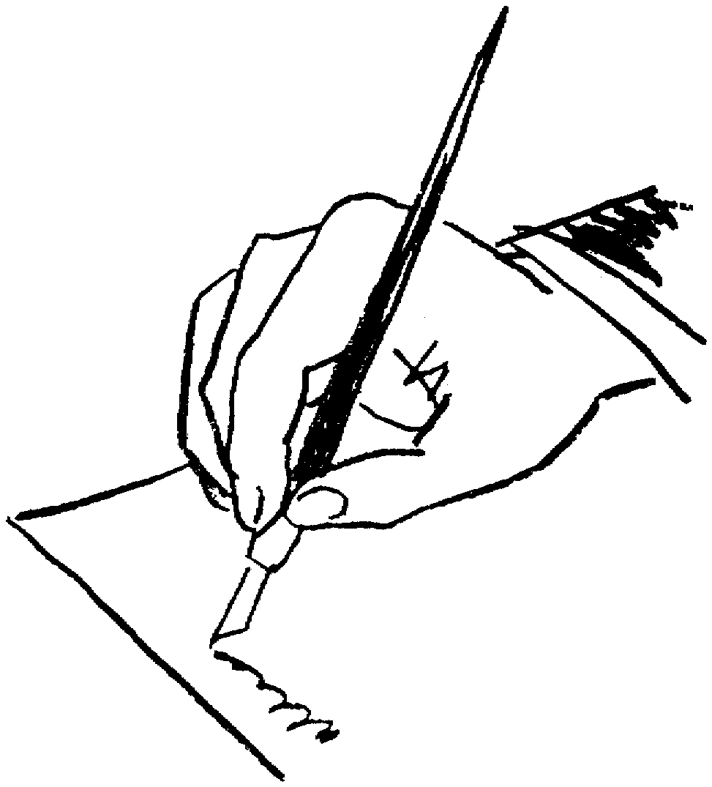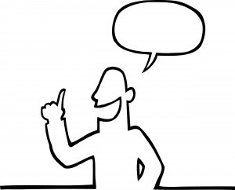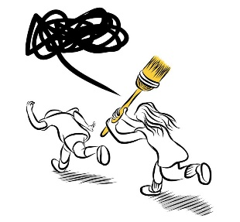
I CHASE

I SPEAK
I WRITE

[1]
5 Match up the Greek to the English

ἀκουει we go
παυετε they chase
διωκουσι you (pl.) stop
βαινομεν he hears
[4]

Turn over

6 Which one of these Greek sentences means:
“I hear the shout”? Tick (✓) the correct box.

ἀκουω την βοην.

OR

ἀκουω την κωμην

[1]

Part 2: Comprehension and Translation Skills
Odysseus and the Cyclops
ὁ Ὀδυσσεὺς εἰς ἄντρον βαίνει. λέγει: “βούλην ἔχω. ὁ Κυκλωψ τὰς οἶς ἄγει πρὸς τὸν ποταμόν.”
οἱ σύμμαχοι λέγουσιν: “ὦ στρατηγέ, δόρυ εἰς ὀφθαλμὸν φέρεις καὶ τὴν νίκην ἔχομεν.”

Some words to help you:
ἄντρον | Cave
οἶς | Sheep
σύμμαχοι | From σύμμαχός, “Allies”
στρατηγέ | From στρατηγός
δόρυ | Spear (accusative)
ὀφθαλμὸν | From ὀφθαλμός, “eye”

Answer two of these questions about the words in bold.
1 Who is the subject of βαίνει?
[ ]
2 How do you know that βούλην is the direct object?
[ ]
3 Is λέγουσιν singular or plural?
[ ]
4 ὁ Κυκλωψ τὰς οἶς ἄγει πρὸς τὸν ποταμόν. Can you translate this sentence?
__________________________________________________________ [ ]

Choose one of the following three topics and discuss it briefly.
- What was the importance of xenia for the Greeks?
- What was the importance of stories for the Greeks?
- What was the importance of nostos (homecoming) for Odysseus in the Odyssey?

END

