Reading a Roman Recipe - Wild Boar
The Romans would eat a whole boar when they had a small party. Boars are a kind of wild pig that was very common in Roman Britain. If you want to cook boar you need a very large oven, or a very small boar, but the recipe is just as tasty with small pieces of boar instead. Once you have cleaned the boar you can scatter plenty of sea salt, crushed pepper and ground roasted spices over it. Leave it in the fridge for 2-3 days, turning it occasionally.
Wild boar can be dry, so wrap it in slices of bacon before you roast it. Then put it into the oven at its highest setting and allow it to cook for 10 minutes. Reduce the oven temperature to 180 degrees, and continue to roast for 2 hours per kg, basting regularly.
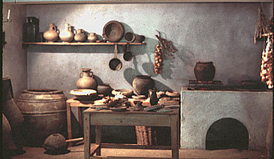
Meanwhile prepare the sauce. To make Roman sauce, boil 500 millilitres. Add 2 tablespoons of honey, and add salt to taste. Take the meat out of the oven and leave it to rest while you finish the sauce. Pour off the fat from the roasting tin. Finally glaze the boar with the wine and the honey mixture. Pour the fat and sauce into a saucepan and you will have made roman sauce.

Can you answer these questions?
Q1.How much boar could a small roman party have?
- A whole boar. B) Two whole boars. C) 5 whole boars.

Q2. What country were Boars very common in?
- America. B) Australia. C) Britain.

Q3. How many days should you leave the boar in the fridge?
- 1 Day. B) 2-3 Days. C) 5 Days.

Q4. Why should you wrap a Boar in Bacon before cooking it?
- Because it makes it tasty.
- Because it stops it from being dry when cooked.
- Because it makes it look pretty.

Q5. How hot should the oven be after 10 minutes?
- 180 degrees. B) 360 degrees. C) 100 degrees.

Q6. What do you add to Roman sauce to make sure it tastes sweet.
- Honey. B) Fishes. C) Chocolate.

Q7.What type of animal is a boar?
- It’s a kind of fish. B) It’s a kind of bird. C) It’s a kind of pig.

