Liber Faciei | Domus Amici Nuntia (2) |  |  |  | Constituta | Exit
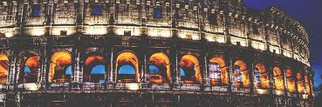
 |  |  | :
How are you feeling?
Loca
Amici
Adde imagines
Innova statum

Historia _____________________________________________________________________

Genus: Puer/Puella
Habito:
Dies Natalis:
Fundamenta _________________________________________________________________

Amo:

kj
Ludus et Curriculum ___________________________________________________________

Ludus:
Magister:

View photos of me (34)
Caesar: Get the feeling someone’s going to stab me in the back #suspicious
Pompeians: Volcano due to erupt in the next 150 years #Vesuvius
Historia
Habito: |  | Familia:
Dies Natalis:
Amici
Caesar |  | Ovidius |  | Cleo
Virgilius |  | Augustus |  | Horatius

Some Vocabulary

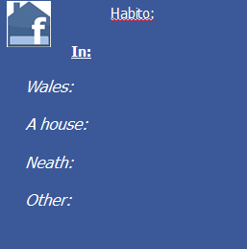
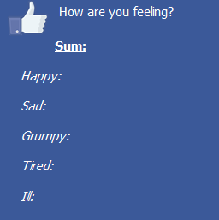
Cambria
Domus
Nidum
Alius
Laetus
Tristis
Iratus
Fessus
Malus

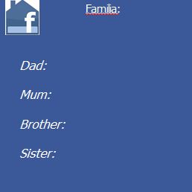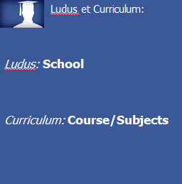
Pater
Mater
Frater
Soror

Amo:

Musicam music
Cantare singing
Ludum sport
Feriam holiday

